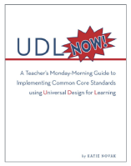
Book Study Questions
Introduction, Chapter 1 & 2
January 14, 2016
4pm or 8pm E/T

www.UDLBookStudy.Weebly.com
Questions | Comments | Extensions
1.1 Please tell us who you are, where you are from, and why you joined this book study? |  | Deep Dive into the UDL Guidelines or  http://bit.ly/1RhILXQ
1.2 After reading Chapter 1, what resonated with you or grabbed your attention?
1.3 How does the concept of teacher efficacy affect student learning?
2.1 The deficit model blames student failure on students, their parents, and the community. Where are you with your thinking?
2.2 How do you respond to, “If behavior is a barrier, remove the barrier, not the student.”
2.3 Think of the best lesson you have ever taught. How did you know it was such a success? Which guidelines/ checkpoints were at work in that lesson?

